Date: 5 – 6 November 2026
Registration 5 November 2026: 08:30 am – 09:00 am

Official Conference Venue

University of Dar es Salaam, University Road, Mlimani Campus, Dar es Salaam, Tanzania

Conference Registration – All delegates, speakers, paper presenters, sponsor organisation representatives must register online using the following link:
Please be sure to register to attend the BEN Africa Conference, certificates of attendance is earned.

Contact/In-person* Registration and paper submissions
BEN-Africa Member Registration R5000 (Approx. USD $300)
Standard Attendee Registration R6000 (Approx. USD $360)
Virtual/Online Attendee Registration R500 (Approx. USD $30)
*All Paper Presenters are required to pay in-person registration fees.
Online registration required in advance, link to be provided 24 hours before conference

Please note that the BEN-Africa Conference Team will not be providing any travel-related coordination services for delegates. The conference will be hosted in person, and conference fees as outlined above are to be prepaid no later than 28 October 2026 to confirm registration.
Delegates are responsible to coordinate all their own daily transport between the conference venue (Dar es Salaam University) and the chosen accommodation.
Suggested Conference Accommodation
Hotel 1: Hotel White Sands Resort (Beachfront) https://hotelwhitesands.com/
Africana Road, Jangwani Beach, Dar es Salaam, Tanzania
- Standard Seaview Room - $120 per night for single occupancy inclusive of breakfast; For double occupancy please add $20
- Executive room (one bedroom apartment style room) - $220 per night for single occupancy inclusive of breakfast; For double occupancy please add $25
- Guests can book their room directly with Hotel White Sands by using the email address and mention in the subject – Ben Africa; Email to rdm@hotelwhitesands.com copy info@hotelwhitesands.com Phone: +255 758 818 696-699 www.hotelwhitesands.com
Transport: White Sands have their own airport transfer vehicle; delegates must contact the hotel directly. Alternative contact for transport +255 715 511 022.
Hotel 2: Wanyama Hotel (About 4km from the Dar es Salaam University Business school): This hotel is recommended by the University.
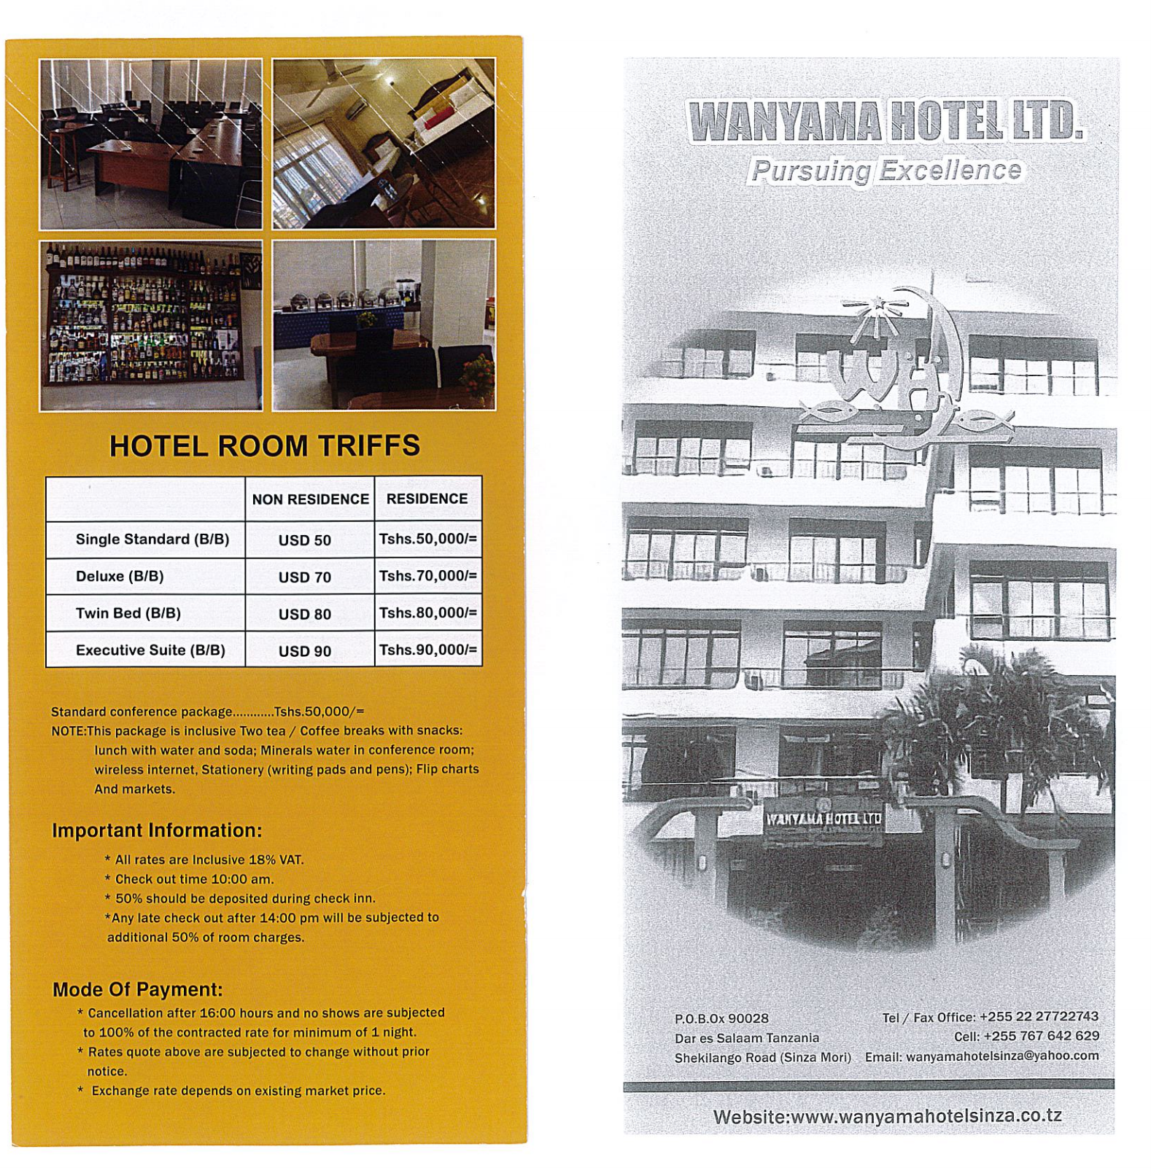
Email: wanyamahotelsinza@yahoo.com / Phone +255 22 2777 22 743

Kindly note that participants need to cover their own accommodation and travel expenses, BEN-Africa is a non-profit entity and unable to provide funding.

Tourism information about Tanzania: https://destinationtanzania.tz/portal/home
Visa Information
Visitors to Tanzania (https://visa.immigration.go.tz/) must review the requirements as posted on the website (https://visa.immigration.go.tz/guidelines|)
You can apply for an Online Visa to visit the United Republic of Tanzania (both Tanzania Mainland and Zanzibar). You are required to fill in the online form, make payment, and submit your application online. Your form will be internally reviewed and processed.
Applicants will be notified through their e-mails whether their applications have been accepted or rejected. They may also TRACK their application statuses through the online system. Applicants may as well be required to visit the nearest Tanzanian Embassies or Consular Offices for interviews (https://visa.immigration.go.tz/).
Requirements for entering Tanzania
- A valid and acceptable passport or travel document for your intended stay
- At least one blank page in your passport for endorsements
- A valid visa, if required (visit https://visa.immigration.go.tz/)
- Sufficient funds to pay for your day-to-day expenses during your stay
- A return or onward ticket
- Tanzania’s Ministry of Health states that proof is required for travellers arriving from yellow-fever-endemic countries, including certain extended transits.

Getting to and around in Dar es Salaam
Uber does not operate in Dar es Salaam, but BOLT is widely available.

Currency
The shilling (Swahili: shilingi; abbreviation: TSh; code: TZS) is the currency of Tanzania. It is subdivided into 100 cents (senti in Swahili). Currency indicator only as of 18 September 2026 USD $1 = TSh 2650,00).
Languages
Swahili: Spoken by about 90% of the population, with English as the second language.
Safety Tips
At the Airport:
- Watch out for staged mishaps - like someone bumping into you or spilling a drink - this could be a ploy to divert your attention and steal your bag and passport;
- When seeking directions, proceed to marked information counters only;
- Do not take cabs that have been recommended by people standing outside the airport terminal.
- Double check the identification of a driver to ensure that they have a valid employment id.

At your Accommodation
- Store valuables in the safety deposit box;
- Keep your room locked;
- If someone knocks, check who it is before opening the door. Contact reception if you have any reason for concern;
- Make sure that luggage is only given to bell staff, and a receipt is issued for stored luggage;
- Do not leave unattended valuables on chairs, under tables or on restroom hooks.

On the Street:
- Avoid ostentatious display of expensive jewellery, cameras, mobile phones and other valuables;
- Keep your handbag closed or zipped, and your wallet in an inside pocket and not in the rear pocket of your trousers;
- Do not leave luggage unattended. It is ill-advised to carry large sums of money with you;
- Do not walk around talking on your mobile phone in the street and do not leave your phone unattended;
- Exchange your currency at a bank or at the hotel, not on the street.



